**Assignment-3: Word Count using Map Reduce**

**Chaitanya Sai Nutakki  
AP21110010253**

**GETTING JAR FILE TO ROOT DIRECTORY**

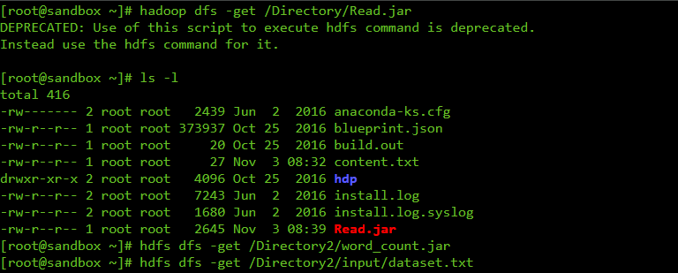

**CREATING OUTPUT FOLDER BY RUNNING THE CODE**

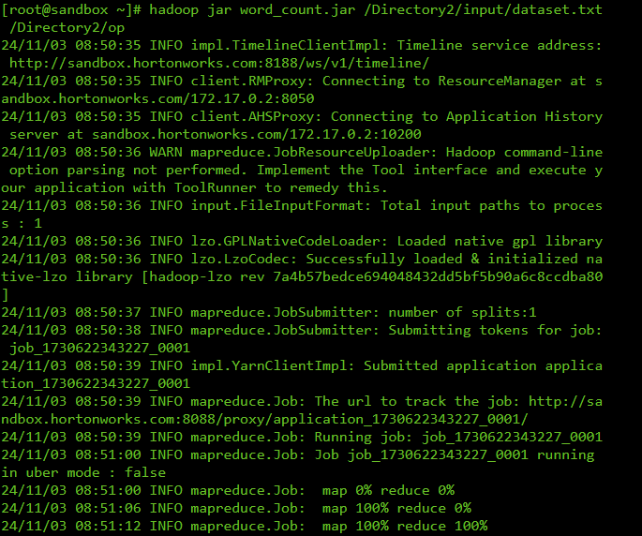

**OUTPUT TEXT FILE**

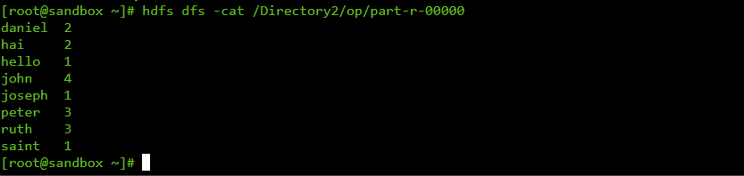

**FILE PREVIEW**